Project 2

<Master Mind>

**CSC5-45276**

**Name: Javier Borja**

**Date: 7/28/2016**

Table of Contents

Introduction 2

Tutorial 3

Learn how to play: 4

Sample gameplay 4

Project Summary 5

Pseudocode and Flowcharts 6

Main: 7

Game Function: 8

Turn Function: 8

Results Function: 9

Read Function: 10

Menu Function: 10

Help Function: 11

Sort Function: 11

Sort Function: 11

LeaderBoard Function: 12

Major Variables: 12

Concepts utilized: 13

Code: 15

# Introduction

Master Mind

For Project 2 in CSC-5, I have decided to continue my Project 1 of Master Mind because my original program felt incomplete and improvable. I originally decided to recreate this board game because it was one of my favorite games growing up.

The basis of the game is for one player to create a code (code-maker) and for one player to break the code (code-breaker). The original board game sports 6 colored pegs and 4 holes. The code-maker must choose 4 pegs, duplicates allowed, and place them in a hidden row. This is the only concern for the code-breaker, he is allowed 8-12 turns to solve the puzzle. The code-maker gives feedback after every guess by filling 4 smaller holes with black and white pegs. The black peg corresponds to a correct colored peg and position, while a white colored peg corresponds to just a correct colored peg. The game is over when the code-breaker runs out of rows (or turns) and fails to guess the code-maker’s combination or if the code-breaker successfully solves the code.

The original board game is based on an earlier pencil and paper game called Bulls and Cows, which this program resembles the most, because of the limitations of my programming skills. This game uses numbers instead of colored pegs, but the goal and general impression are the same. The user must guess the Ai’s combination in 8 or 12 turns, and duplicate numbers are allowed depending on which mode the user has chosen. My version of the classic game uses 8 numbers instead of the usual 6, which means there are 8^4 or 4096 possible combinations, with duplicates numbers allowed.

# Tutorial

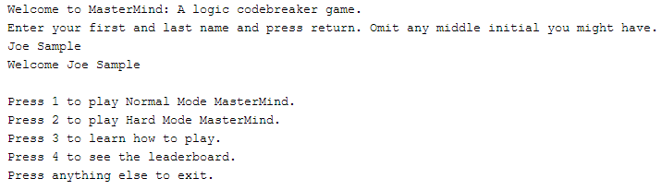 This program is straightforward and easy to understand. Your experience begins with a welcome screen, in here you will input your first and last name, and then you’ll be displayed the menu with 4 different options.

These options are self-explanatory. Selecting 1 or 2 lets you play Master Mind in different difficulty settings, selecting 3 shows you how to play the game, and selecting 4 lets you see the current leaderboard. You are asked for a name in the beginning of the program so you are able to show up in the leaderboard. The leaderboard is sorted by amount of wins per session.

**Leaderboard:**

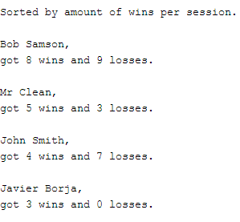

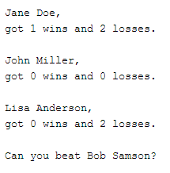

Learn how to play:

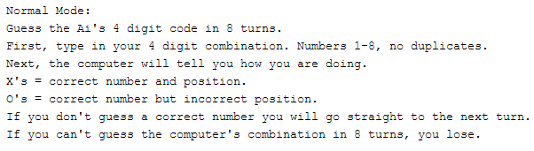

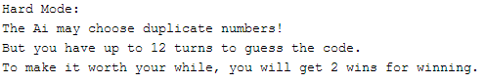

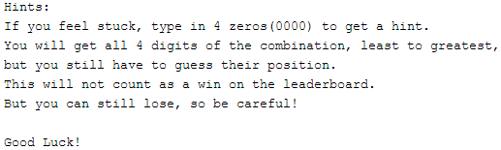

# **Sample gameplay**

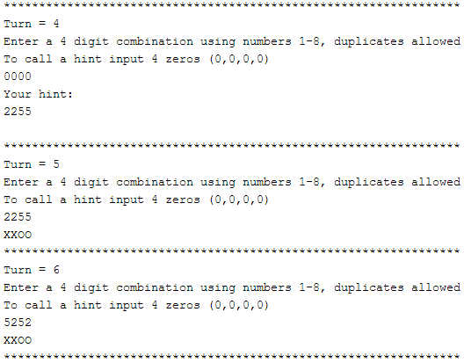

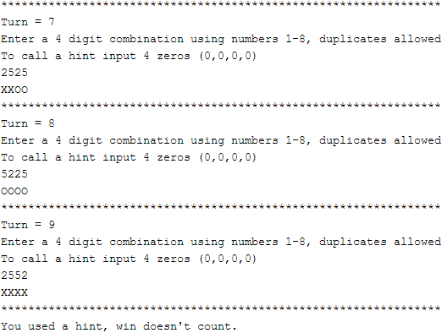

Project Summary

|  |  |
| --- | --- |
| Project size | 456 Lines |
| Lines of code | 398 Lines |
| Comment lines | 38 Lines |
| Blank lines | 20 Lines |

Project 1 was developed in versions 1-3; Project 2 was continued in version 4. I will be summarizing the development cycles in brief synopses. You may see the development process in my GitHub repository. Running code from previous versions may not work and is not advised.

<https://github.com/javierborja95/JB_CSC5/tree/master/Project>

Version 1

Most of the program was written in version one. The main game and turn functions were developed in this stage. Reading the rules from another file and writing to another file was not working properly and many debugging output statements are included.

Version 2

Two new functions were added. A menu function which displays the menu and the results function that displays the results of the game. Formatting was improved in the game function and the rules function was working properly.

Version 3

Output formatting is finalized in this version. Win/loss counter is working correctly, writing results to file working properly, and all debugging statements are removed.

Version 4

Project 2 begins in this stage, major variables are removed and replaced with arrays.

Version 5

Created 2 new functions, Normal mode and Hard mode of the Master Mind game. Normal mode max turns were lowered to 8 turns and Hard mode was upped to 12. The turn function broke because the original game was programmed with no duplicate numbers in the code allowed.

Version 6

A help function was developed to give the player a hint if he was stuck. This was made as a compliment to the new Hard mode. The rules were updated to reflect the new modes and the results were updated to accommodate all the new options. New outputs were made depending on the mode and if a hint was used.

Version 7

Merged the Hard mode and Normal mode into a single game function. Attempts to fix the turn function were made. Further testing revealed the problem and solution.

Version 8

Final version. Turn function fixed for good and major improvements are made to the rest of the program. I developed a working leaderboard and created a structure to use relevant major variables in the main and leaderboard functions. Concluding output is finalized and key testing was performed to confirm a working program.

# Pseudocode and Flowcharts

//Function prototypes

Game

Turn

Help

Read

Menu

Sort //Sort for hint

Sort //Sort for leaderboard

Swap

Leader Board

Result

## Main:

Input name

Output menu

Input choice

Switch (choice)

Case 1: Normal Mode

Case 2: Hard Mode

Case 3: How to play

Case 4: Leaderboard

Default end program

If win

Win++

Else

Loss--

Output wins/losses

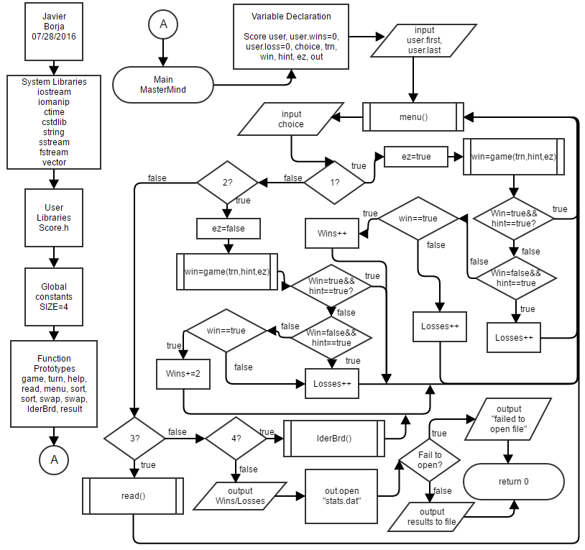Write results to file

## Game Function:

Get random 4-digit combination

If normal mode {

Repeats not allowed.

Max turns = 8

} Else {

Repeats allowed

Max turns = 12

}

Turn function until max turns or player wins

Results function 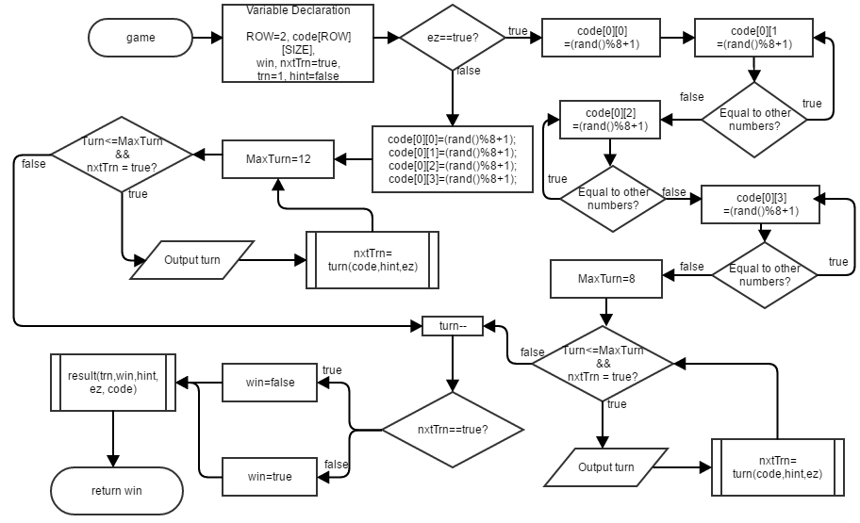

## Turn Function:

Input player 4-digit combination

Correct number and position?

Output X

Correct number and incorrect position?

Output O

If 0000

Call help function

If combinations match

Win=true

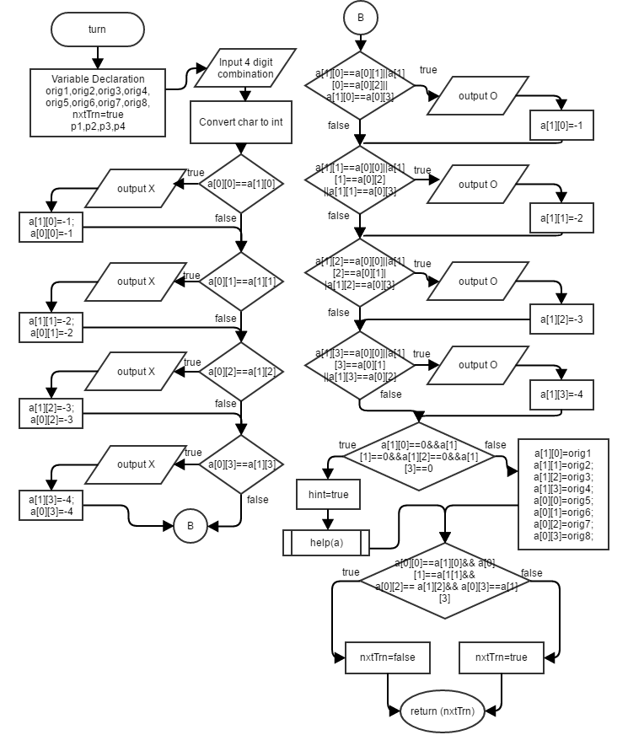

## Results Function:

If (Win==false)

Output “You Lose”

If (hint==true)

Output “Win doesn’t count”

Normal mode true?

Switch(turns)

Case 1-8: Output “You win normal mode”

Else Switch(turns)

Case 1-12 Output” You win hard mode”

//Different messages display depending on which turn you win

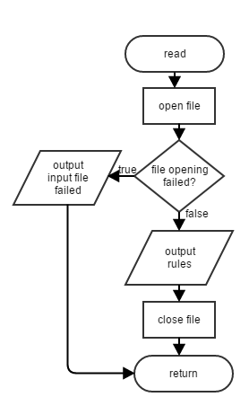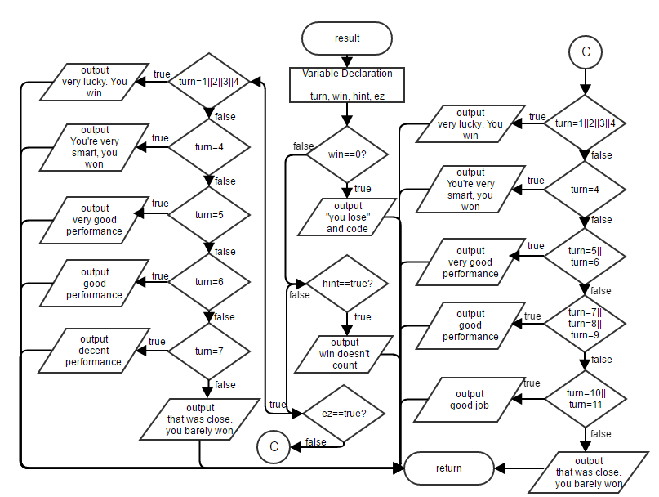

## Read Function:

Open rules file

Output rules

Close rules file

## Menu Function:

Output menu options

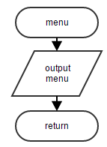

## Help Function:

New Array=Old Array

Sort New Array

Output new array

## Sort Function:

(Array > Array at next position?)

Swap array

## Sort Function:

Do {

(Vector < Vector at next position?) {

Swap vector

Go Again=true

}

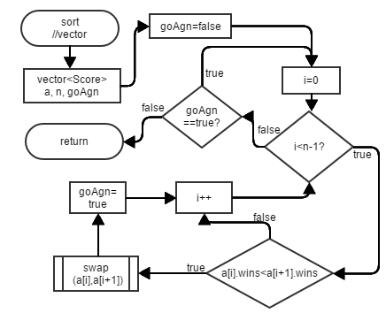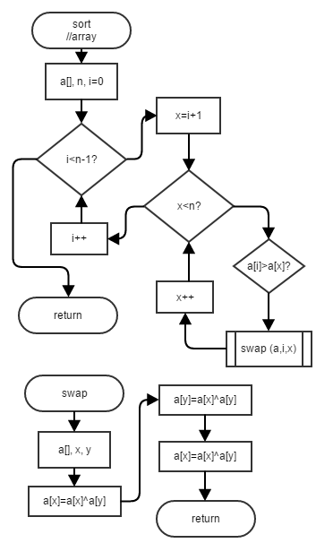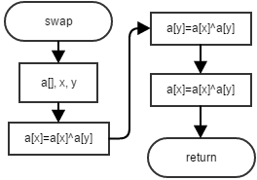} While (Go Again==true)

## 

## 

## 

## LeaderBoard Function:

Open “stats.dat”

}

Input into wins

Input into losses

Input in name

} While (Not end of file)

Call Sort function

Output Name, wins and losses

Output best player

# Major Variables:

|  |  |  |  |
| --- | --- | --- | --- |
| **Type** | **Variable Name** | **Description** | **Location** |
| struct | Score | Contains user and players info | Score.h, main, lderBrd |
| Score | user | Contains the user’s information | main |
| vector<Score> | player | Contains other players’ information | lderBrd |
| char | choice | Menu choice | main |
|  | p1 | Player first number choice | turn |
|  | p2 | Player second number choice | turn |
|  | p3 | Player third number choice | turn |
|  | p4 | Player fourth number choice | turn |
| int | SIZE | Size of the code (4) | main, game, turn, result, help |
|  | ROW | Size 2 of the code array | game |
|  | MAX | Max amount of players in leaderboard (100) | lderBrd |
|  | trn | What turn user is on | main, game, turn, result, |
|  | maxTrn | Max turn | game |
|  | orig1,orig2,orig3,  orig4,orig5,orig6,  orig7,orig8 | Original values of code array | turn |
|  | count | Amount of players in leaderboard | lderBrd |
|  | code | Array of Ai code and playerCode | main, game, turn, help |
|  | user.win | User amount of wins | main |
|  | user.loss | User amount of losses | main |
|  | player.wins | Players’ wins | lderBrd |
|  | player.loss | Players’ losses | lderBrd |
| bool | win | Game result | main, game, result |
|  | hint | Used to track if user used a hint | main, game, result |
|  | ez | Normal mode or hard mode | main, game, result |
|  | nxtTrn | Decides whether to go to a next turn | game, turn |
|  | goAgn | Decides whether to loop sort function again | sort |
| ofstream | out | Writes results to a file | main |
| ifstream | line | Gets lines from files | read, lderBrd |
| string | user.first | User first name | main |
|  | user.last | User last name | main |
|  | player.first | Player’s first names | lderBrd |
|  | player.last | Player’s last names | lderBrd |
| stringstream | ss1,ss2,ss3,ss4 | Used to convert char to int | turn |

# Concepts utilized:

From Walter Savitch, *Problem Solving with C++*, Ninth Edition.

|  |  |  |
| --- | --- | --- |
| **Chapter** | **Construct** | **Location** |
| 2.1 | Variables and Identifiers | char choice; |
|  | Assigned statements | ez=true; |
| 2.2 | Input and Output | cin>>choice;  cout<<endl; |
|  | Escape sequences | cout<<"Press 3 to learn how to play.\n" |
| 2.3 | Number types | int trn; |
|  | Type char | char choice; |
|  | Type bool | bool win; |
|  | Class string | string first |
| 2.4 | If-else statement | if(win==true) user.wins+=2;  else user.loss++; |
|  | Boolean expressions | if(nxtTrn==true) |
|  | Compound statements | if(a[0][0]==a[1][0]){  cout<<"X"; a[1][0]=-1;  a[0][0]=-1; } |
|  | While loop | while(goAgn==true) |
|  | Increment and decrement operator | user.wins++;  trn--; |
| 2.5 | Naming constants | const int SIZE=4; |
| 3.2 | Nested statements | else{  switch(turn){ |
|  | Switch statements and menus | switch(choice){ |
| 3.3 | For statement | for(int maxTrn=8; (trn<=maxTrn&&nxtTrn==true);trn++) |
| 3.4 | Sentinel values | "Press anything else to exit."<<endl;  cin>>choice; |
| 4.1 | Functions | bool game(int &turn,bool&,bool); |
| 4.2 | Random Number Generation | code[0][0]=(rand()%8+1) |
|  | Type Casting | srand(static_cast<unsigned int>(time(0))); |
| 4.3 | Programmer defined functions | bool turn(int[][SIZE],bool&,bool); |
|  | Pass-by-value | result(trn,win,hint,ez,code); |
|  | Return statements | return(nxtTrn); |
| 4.5 | Local variables | void read(){  ifstream line; |
| 4.6 | Overloading Function Names | void sort(int[],int;  void sort(vector<Score>&,int); |
| 5.1 | Void Function | void menu(); |
| 5.2 | Call-by-reference | bool game(int &turn,bool&,bool); |
| 5.3 | Function calling functions | void lderBrd(){  sort(player,count); |
| 6.1 | Streams and File I/O | ofstream out;  ifstream line; |
|  | Writing to File | out<<'\r'<<user.wins<<' '<<user.loss |
|  | Appending to a File | out.open("stats.dat",ios::app); |
| 6.2 | Manipulators | cout<<"Wins this session"<<setw(5)<<"= "  <<user.wins<<endl; |
| 6.3 | Defaulted Parameters | bool game(int &turn,bool&,bool=true); |
| 7.1 | Arrays | int code[ROW][SIZE]; |
| 7.2 | Arrays in Functions | void help(int a[][SIZE]){ |
| 7.3 | Sorting an Array | void sort(int a[],int n){ |
| 7.4 | Multidimensional Arrays | int code[ROW][SIZE]; |
| 8.2 | I/O with String Class | while(getline(line,string)){ |
| 8.3 | Vectors | vector<Score> player(MAX); |
| 10.1 | Structures | struct Score{  int wins; int loss; string first; string last;  }; |
| Other | Stringstream | ss1<<p1 ss1>>a[1][0]; |

# Code:

/*

* File: Score.h

* Author: Javier B

* Created on July 27, 2016, 5:24 PM

*/

#ifndef SCORE_H

#define SCORE_H

using namespace std;

struct Score{

int wins;

int loss;

string first; //Name

string last; //Name

};

#endif // SCORE_H

/*

* File: main.cpp

* Author: Javier Borja

* Created on July 27, 2016, 3:40 PM

* Purpose: Player guesses a 4 digit combination against the computer.

*/

//System Libraries

#include <iostream> //Input/ Output Stream Library

#include <iomanip> //Output Manipulation

#include <ctime> //Computer Time for seed

#include <cstdlib> //Library for random number seed

#include <string> //String library

#include <sstream> //String Stream Library

#include <fstream> //File I/O

#include <vector> //Vectors

using namespace std; //Namespace of the System Libraries

//User Libraries

#include "Score.h"

//Global Constants

const int SIZE=4; //Size of code

//Function Prototypes

bool game(int &turn,bool&,bool=true);//A single game of MasterMind

bool turn(int[][SIZE],bool&,bool); //A single turn of mastermind

void help(int[][SIZE]); //Hint

void read(); //Read rules

void menu(); //Menu

void sort(int[],int); //Sort hint

void sort(vector<Score>&,int); //Sort leaderboard

void swap(int[],int,int); //Swap

void lderBrd(); //Leaderboard

void result(int,bool,bool,bool,int[][SIZE]); //Result of game

//Execution

int main(int argc, char** argv) {

//Set Random seed

srand(static_cast<unsigned int>(time(0)));

//Variables

Score user; //Player

user.wins=0; //Wins

user.loss=0; //Losses

char choice; //Menu choice

int trn; //Turn

bool win; //Game result. True results in win

bool hint; //Hint

bool ez; //Difficulty easy or hard

ofstream out; //Output results to file

//Input Data

cout<<"Welcome to MasterMind: A logic codebreaker game.\n"

"Enter your first and last name and press return. Omit any middle"

" initial you might have."<<endl;

cin>>user.first>>user.last;

//Process Data & Menu

cout<<"Welcome "<<user.first<<" "<<user.last<<endl<<endl;

do{

menu();

cin>>choice;

cout<<endl;

switch(choice){

case'1':

win=game(trn,hint);

if(hint==true&&win==true)

break;

if(hint==true&&win==false){

user.loss++;

break;

}

if(win==true)

user.wins++;

else

user.loss++;

break;

case'2':

ez=false;

win=game(trn,hint,ez);

if(hint==true&&win==true)

break;

if(hint==true&&win==false){

user.loss++;

break;

}

if(win==true)

user.wins+=2;

else

user.loss++;

break;

case'3':read();break;

case'4':lderBrd();

}

}while (choice=='1'||choice=='2'||choice=='3'||choice=='4');

//Output Data and output to file

cout<<"Thanks for playing "<<user.first<<" "<<user.last<<endl;

cout<<"Wins this session"<<setw(5)<<"= "<<user.wins<<endl;

cout<<"Losses this session = "<<user.loss<<endl;

out.open("stats.dat",ios::app); //Append to file

if (out.fail())

cout<<"Input file 1 opening failed.\n";

out<<'\r'<<user.wins<<' '<<user.loss<<' '

<<user.first<<' '<<user.last;

out.close();

return 0;

}

bool game(int &trn,bool &hint,bool ez){

//Set variables

const int ROW=2; //Two codes, Ai choice and player choice

int code[ROW][SIZE]; //2x4 Array

bool win;

bool nxtTrn;

nxtTrn=true; //Decides to go to next turn

//Process Data and get random combination

trn=1;

hint=false;

if(ez==true){

//Normal Mode

code[0][0]=(rand()%8+1);

do{

code[0][1]=(rand()%8+1);

}while (code[0][1]==code[0][0]); //No duplicates

do{

code[0][2]=(rand()%8+1);

}while (code[0][2]==code[0][1]||code[0][2]==code[0][0]); //No duplicates

do{

code[0][3]=(rand()%8+1);

}while (code[0][3]==code[0][2]||code[0][3]==code[0][1]|| //No duplicates

code[0][3]==code[0][0]);

for(int maxTrn=8;(trn<=maxTrn&&nxtTrn==true);trn++){//Max turns 8

cout<<"Turn = "<<trn<<endl;

nxtTrn=turn(code,hint,ez);

}

}

else{

//Hard Mode

code[0][0]=(rand()%8+1); //Duplicates allowed

code[0][1]=(rand()%8+1);

code[0][2]=(rand()%8+1);

code[0][3]=(rand()%8+1);

for(int maxTrn=12;(trn<=maxTrn&&nxtTrn==true);trn++){//Max turns 12

cout<<"Turn = "<<trn<<endl;

nxtTrn=turn(code,hint,ez);

}

}

trn--; //Offset the extra turn from end of loop

if(nxtTrn==true)

win=false; //Lose if the game still wants to go to another turn

else win=true; //Win if game doesn't need to go to another turn

//Output Result

result(trn,win,hint,ez,code);

return(win);

}

bool turn(int a[][SIZE],bool& hint,bool ez){

//Declare Variables

int orig1,orig2,orig3,orig4,orig5,orig6,orig7,orig8;

bool nxtTrn;

nxtTrn=true;

stringstream ss1,ss2,ss3,ss4;

char p1, p2, p3, p4;//Strip 4 character combination to 4 separate ints

//Input Data

if(ez==true)

cout<<"Enter a 4 digit combination using numbers 1-8, no duplicates"<<endl;

else

cout<<"Enter a 4 digit combination using numbers 1-8, duplicates allowed\n";

cout<<"To call a hint input 4 zeros (0,0,0,0)"<<endl;

cin>>p1>>p2>>p3>>p4; //Input player, 4 character combination

//Process Data

ss1<<p1; ss1>>a[1][0]; //Convert char to ints

ss2<<p2; ss2>>a[1][1];

ss3<<p3; ss3>>a[1][2];

ss4<<p4; ss4>>a[1][3];

orig1=a[1][0]; orig5=a[0][0]; //Copy original Values

orig2=a[1][1]; orig6=a[0][1];

orig3=a[1][2]; orig7=a[0][2];

orig4=a[1][3]; orig8=a[0][3];

//Output Data

if(a[0][0]==a[1][0]){ //If number and position match

cout<<"X";

a[1][0]=-1; //Change value to prevent duplication bugs when

a[0][0]=-1; // comparing with other digits

} //Prevents outputs like 'XXXOOO'

if(a[0][1]==a[1][1]){ //If number and position match

cout<<"X";

a[1][1]=-2;

a[0][1]=-2;

}

if(a[0][2]==a[1][2]){ //If number and position match

cout<<"X";

a[1][2]=-3;

a[0][2]=-3;

}

if(a[0][3]==a[1][3]){ //If number and position match

cout<<"X";

a[1][3]=-4;

a[0][3]=-4;

}

if(a[1][0]==a[0][1]||a[1][0]==a[0][2]||a[1][0]==a[0][3]){ //If numbers match

cout<<"O";

a[1][0]=-1;

}

if(a[1][1]==a[0][0]||a[1][1]==a[0][2]||a[1][1]==a[0][3]){ //If numbers match

cout<<"O";

a[1][1]=-2;

}

if(a[1][2]==a[0][0]||a[1][2]==a[0][1]||a[1][2]==a[0][3]){ //If numbers match

cout<<"O";

a[1][2]=-3;

}

if(a[1][3]==a[0][0]||a[1][3]==a[0][1]||a[1][3]==a[0][2]){ //If numbers match

cout<<"O";

a[1][3]=-4;

}

if(a[1][0]==0&&a[1][1]==0&&a[1][2]==0&&a[1][3]==0){

hint=true;

help(a);

}

a[1][0]=orig1; //Set back to original values

a[1][1]=orig2;

a[1][2]=orig3;

a[1][3]=orig4;

a[0][0]=orig5;

a[0][1]=orig6;

a[0][2]=orig7;

a[0][3]=orig8;

nxtTrn=(a[0][0]==a[1][0]&&a[0][1]==a[1][1]&&

a[0][2]==a[1][2]&&a[0][3]==a[1][3])?false:true;

//If combinations equal then no need for next turn.

if(ez==true) //Different output based on mode, just for program to look pretty

cout<<endl<<"************************************************************";

else

cout<<endl<<"*****************************************************************";

cout<<endl;

return(nxtTrn);

}

void help(int a[][SIZE]){

//Declare Variables

int b[SIZE]; //Original array, sorted

//Input data

for(int i=0;i<SIZE;i++){

b[i]=a[0][i];

}

//Process Data

sort(b,SIZE);

//Output Data

cout<<"Your hint:"<<endl;

for(int i=0;i<SIZE;i++){

cout<<b[i];

}

cout<<endl;

}

void sort(int a[],int n){

for(int i=0;i<n-1;i++){

for(int x=i+1;x<n;x++){

if(a[i]>a[x]){

swap(a,i,x);

}

}

}

}

void swap(int a[],int x,int y){

a[x]=a[x]^a[y];

a[y]=a[x]^a[y];

a[x]=a[x]^a[y];

}

void sort(vector<Score>& a,int n){

//Declare Variables

bool goAgn;

//Process Data

do{

goAgn=false;

for(int i=0;i<n-1;i++){

if(a[i].wins<a[i+1].wins){

swap(a[i],a[i+1]);

goAgn=true;

}

}

}while(goAgn==true);

}

void result(int turn, bool win,bool hint,bool ez,int a[][SIZE]){//Result of game

//Output Data

if(win==0){

cout<<"You lose!\n"

"Better luck next time.\n"

"The code was actually:"<<endl;

cout<<a[0][0]<<a[0][1]<<a[0][2]<<a[0][3]<<endl<<endl;

return;

}

if (hint==true){

cout<<"You used a hint, win doesn't count."<<endl<<endl;

return;

}

else if(ez==true){

switch(turn){

case 1:

case 2:

case 3:

cout<<"Wow, very lucky. You win!"<<endl;break;

case 4:

cout<<"Congratulations!\n"

"You're very smart, you won in 4 turns!"

<<endl;break;

case 5:

cout<<"Congratulations!\n"

<<"You won in 5 turns. Very good performance!"

<<endl;break;

case 6:

cout<<"Congratulations!\n"

<<"You won in 6 turns. Good performance!"

<<endl;break;

case 7:

cout<<"Congratulations!\n"

<<"You won in 7 turns. Decent performance."

<<endl;break;

default:

cout<<"That was close! You barely won."

<<endl;break;

}

}

else{

switch(turn){

case 1:

case 2:

case 3:

cout<<"Wow, very lucky. You win!"<<endl;break;

case 4:

cout<<"Congratulations!\n"

"You're very smart, you won in 4 turns!"

<<endl;break;

case 5:

cout<<"Congratulations!\n"

<<"You won in 5 turns. Very good performance!"

<<endl;break;

case 6:

cout<<"Congratulations!\n"

<<"You won in 6 turns. Very good performance!"

<<endl;break;

case 7:

cout<<"Congratulations!\n"

<<"You won in 7 turns. Good performance!"

<<endl;break;

case 8:

cout<<"Congratulations!\n"

<<"You won in 8 turns. Good performance!"

<<endl;break;

case 9:

cout<<"Congratulations!\n"

<<"You won in 9 turns. Decent performance."

<<endl;break;

case 10:

cout<<"Congratulations!\n"

<<"You won in 10 turns. Good job."

<<endl;break;

case 11:

cout<<"Congratulations!\n"

<<"You won in 11 turns. Good job."

<<endl;break;

default:

cout<<"That was close! You barely won."

<<endl;break;

}

cout<<"Because this is hard mode, this win counts as two wins!"<<endl;

}

cout<<endl;

}

void read(){ //Input Rules to display

//Declare Variables

ifstream line;

string string;

//Process and Output Data

line.open("rules.dat");

if(line.fail()){

cout<<"Input file opening failed.\n";

}

cout<<endl;

while(getline(line,string)){

cout<<string<<endl;

}

line.close();

cout<<endl<<endl;

}

void menu(){

cout<<"Press 1 to play Normal Mode MasterMind.\n"

"Press 2 to play Hard Mode MasterMind.\n"

"Press 3 to learn how to play.\n"

"Press 4 to see the leaderboard.\n"

"Press anything else to exit."<<endl;

}

void lderBrd(){

//Declare Variables

int MAX=100;

vector<Score> player(MAX);

ifstream line;

int count=0;

//Process and Output Data

line.open("stats.dat");

if(line.fail()){

cout<<"Input file opening failed.\n";

return;

}

cout<<"Sorted by amount of wins per session."<<endl;

do{

line>>player[count].wins;

line>>player[count].loss;

line>>player[count].first;

line>>player[count].last;

count++;

}while(!line.eof());

sort(player,count);

for(int i=0;i<count;i++){

cout<<endl;

cout<<player[i].first<<" "<<player[i].last<<",\ngot "<<player[i].wins

<<" wins and "<<player[i].loss<<" losses."<<endl;

}

cout<<endl;

cout<<"Can you beat "<<player[0].first<<" "<<player[0].last<<"?"<<endl<<endl;

}